

Cairo University

Faculty of Engineering

Computer Engineering Department



**Rmagine**

A Graduation Project Report submitted to the Faculty of Engineering, Cairo University in Partial Fulfillment of the B.Sc. Degree in Computer Engineering.

Presented by

|  |  |
| --- | --- |
| **Ahmed Mohamed** | **Alaa Sayed** |
| **Raneem Medhat** | **Mohamed Mayla** |

Supervised by

**Prof. Magda Fayek**

Sponsored by



**July 2015**

# **Acknowledgment**

First of all, we want to thank **Allah** for everything; for supporting us in every moment, helping us in everything and giving us the patience, strength and ability to stand till the end.

Then, we would like to thank **our parents**, for their support, encouragement, quiet patience, tolerance of our occasional bad moods and prayers for us.

We would like also to express our sincere appreciation and thanks to **Prof. Magda Fayek**, you have been a tremendous mentor for us. We want to thank you for your unwavering support, encouragement, constant guidance, valuable time, inspiring discussions and valuable suggestions.

Great thanks go to **Eng. Eslam Kamal** our mentor in Microsoft Advanced technology Labs at Cairo for the great efforts he did in guiding, supporting and providing us with constant feedback. We are truly grateful for all the efforts you and **Microsoft** did to support our project technically and financially.

We would like to thank **Dr. Ahmed Morgan** for his valuable comments.

Thanks are extended to **all professors in our department** ―Computer Engineering Department, who taught us directly in lectures and time crunching projects or by mere communication. Knowing you has enriched us both academically and personally.

Special thanks to **Mohamed Orabi** and **Mohamed Maher** for their help in Rmagine marketing material.

Finally, we wish to thank all those who supported us and helped us complete this project and especially **Ghada Abd El Rahman** and **Martha Mounir**.

*Ahmed, Alaa, Mohamed, Raneem*

# **Abstract**

Natural language is an easy and effective medium for describing visual ideas and mental images. We observed the emergence of natural language understanding systems and how these systems help representing the language through a visual output that can be more appealing and beneficial to users, a popular example for these systems is scene generation systems. Many research papers were published in this field and the accuracy of these systems is in constant improvement.

Inspired from the researches made in this area, we wanted to utilize this technology into an interesting application for smartphone users. We decided to target novel readers and use books and novels as our source for natural language. Our app aims to use the power of augmented reality and cloud technology to enhance the reading experience of novel readers by offering text visualization and a nice reader toolkit with many helpful features.

Our approach was to combine some highlighted techniques in NLP and scene generation, complement them with some popular features for readers, and make it all available on smartphones. The processing power our system need is not trivial and that is why we decided to make our app cloud based, making it also easier to migrate to different platforms as planned in our future work.

The resulted app was satisfying as a first version. During our work to produce the first version of Rmagine, we discovered more techniques that could be implemented in the future to make our system more robust and much more accurate. We are planning to invest more in the user experience, NLP technology and scene generation in the future to enhance our system and make our app ready for the market.

# **Table of Contents**

**Acknowledgment** 2

**Abstract** 3

**Table of Contents** 4

**List of Tables** 7

**List of Figures** 9

**Contacts** 11

**Table of Acronyms and Definitions** 12

**Keywords** 12

**Chapter 1.** **Introduction** 13

1.1. Problem Definition 14

1.2. Project Idea 14

1.3. Motivation and Justification 15

1.3.1. Motivation 15

1.3.2. Educational Value 15

1.4. Domain of Applications 16

1.5. Summary of Approach 16

1.6. Document Overview 16

**Chapter 2.** **Market Survey** 17

2.1. Intended Customers 18

2.2. Current Market 19

2.2.1. IDinasour: 19

2.2.2. NLP Story maker: 20

2.2.3. WordsEye 21

2.3. Our Unique Selling Proposal 21

**Chapter 3.** **Necessary Background** 22

3.1. Natural Language Processing 23

3.2. Parse Tree 23

3.3. Part-Of-Speech Tagging 24

3.4. Lemma 25

3.5. Object Detection 25

3.6. Object Recognition 25

3.7. Hough Transform 26

**Chapter 4.** **System Specifications** 27

4.1. System architecture Overview 28

4.1.1. General Architecture 28

4.1.2. Working Environment 29

4.1.3. Objectives 29

4.1.4. Main Functions 29

4.2. Use Cases 30

4.2.1. Start Client-Server session 30

4.2.2. Visualizing text 30

4.2.3. Starting VR Glass mode 31

4.2.4. Ratings and reviews 31

4.2.5. Translation 32

4.2.6. Wikipedia Search 33

4.3. Dataflow Diagram 34

4.4. System Components 35

4.4.1. Segmentation and detection module 35

4.4.2. OCR module 36

4.4.3. NLP Module 37

4.4.4. Image Retrieval module 40

4.4.5. Graphics engine module 41

4.4.6. Reader toolkit modules 43

4.4.7. Display and Virtual Reality module 45

4.4.8. Communication manager module (Server) 47

**Chapter 5.** **Tools** 50

5.1. OpenCV 51

5.2. Microsoft .NET framework 4.5 51

5.3. Microsoft Visual Studio 2013 52

5.4. Microsoft Azure Services 53

5.5. Tesseract OCR 54

5.6. Stanford corenlp 54

5.7. Goodreads api 55

5.8. Bing search api 55

5.9. Microsoft Translator API 56

5.10. Durovis Dive VR Glass 57

**Chapter 6.** **Test Plan** 58

6.1. Introduction 59

6.1.1. Objectives 59

6.1.2. Testing Strategy 59

6.2. Features to Be Tested 59

6.3. Approach 60

6.3.1. Unit (component) Testing 60

6.3.2. Integration Testing 60

6.3.3. System Testing 60

6.3.4. Functional validation: 60

6.4. Recovery Testing 61

6.5. Testing schedule 61

6.6. Test cases 61

6.6.1. Start text visualization 61

6.6.2. Start VR mode glass 62

6.6.3. Get Ratings & reviews 62

6.6.4. Get translation 63

6.6.5. Wiki Search 64

6.6.6. Start session between server and client 64

**Chapter 7.** **Conclusion and Future Work** 66

7.1. Conclusion 67

7.2. Future Work 68

7.2.1. Advanced Text Processing and understanding 68

7.2.2. Complex scene templates and graphs 68

7.2.3. Prior knowledge learning agents 68

7.2.4. 3D scenes 69

7.2.5. Gesture recognition 69

7.2.6. Further Goodreads integration 69

**References** 70

**Appendix-A: User Manual/Guide** 71

.A.1. Prerequisites 72

A.2. The Rmagine guide 72

A.2.1. starting the app: 72

A.2.2. Navigating through the menu: 73

A.2.3. Getting goodreads rating 76

A.2.4. Translation 77

A.2.5. wiki search 79

**Appendix-B: Feasibility StuDY** 81

B.1. Technical feasibility 82

B.1.1. Hardware Requirements 82

B.1.2. Software Requirements 82

B.1.3. Input and Output 82

B.2. Economic feasibility 82

B.2.1. Cost 82

B.2.2. Benefits 83

B.2.3. Business Model 83

B.3. Operational Feasibility 84

B.3.1. Acceptability 84

B.3.2. Availability 84

B.3. Schedule Feasibility 84

**ملخص** 85

# **List of Tables**

Table 1 Acronyms and definitions 13

Table 4 - 1 Use case 1 31

Table 4 - 2 Use case 2 32

Table 4 - 3 Use case 3 32

Table 4 - 4 Use case 4 33

Table 4 - 5 Use case 5 34

Table 4 - 6 Use case 6 34

Table 4 - 7 BookDetector class details 37

Table 4 - 8 TesseractOCR class details 38

Table 4 - 9 InformationExtractor class details 40

Table 4 - 10 Event class details 40

Table 4 - 11 FileHandler class details 40

Table 4 - 12 ImgRetriev class details 42

Table 4 - 13 TextInput class details 42

Table 4 - 14 MainEngine class details 43

Table 4 - 15 Scene class details 44

Table 4 - 16 SceneObject class details 44

Table 4 - 17 APIGoodReads class details 45

Table 4 - 18 Translator class details 45

Table 4 - 19 ConsoleAPPGetWiki class details 46

Table 4 - 20 Display class details 47

Table 4 - 21 RmagineRequest class details 49

Table 4 - 22 RmagineImage class details 49

Table 4 - 23 RmagineRequestRepository class details 49

Table 4 - 24 Process Executor class details 50

Table 4 - 25 RmagineManager class details 50

Table 6 - 1 Start text visualization test case 63

Table 6 - 2 Start VR mode glass test case 63

Table 6 - 3 Get Ratings & reviews test case 64

Table 6 - 4 Get translation test case 65

Table 6 - 5 Wiki Search test case 65

Table 6 - 6 Start session between server and client test case 66

Table B - 1 Rmagine cost 83

# **List of Figures**

Figure 1-1 Visualizing books in augmented reality. 16

Figure 2- 1 Percentage of smartphone users per age group. 19

Figure 2- 2 Picture of IDinasour app 20

Figure 2- 3 Picture of NLP Story maker 21

Figure 2- 4 Example of scenes generated using wordseye 22

Figure 3 - 1 Constituency-based parse tree example 24

Figure 3 - 2 Dependency-based parse tree example 25

Figure 3 - 3 Example of book detection. 26

Figure 3 - 4 Example of object recognition 27

Figure 3 - 5 Example of hough transform 27

Figure 4 - 1 General architecture diagram 29

Figure 4 - 2 Dataflow diagram of Rmagine 35

Figure 4 - 3 OCR class diagram 37

Figure 4 - 4 NLP class diagram 39

Figure 4 - 5 Bing search api class diagram 41

Figure 4 - 6 Graphics engine class diagram 43

Figure 4 - 7 Rmagine manager class diagram 48

Figure 4 - 8 Rmagine server class diagram 48

Figure 5 - 1 OpenCV logo 52

Figure 5 - 2 .Net logo 52

Figure 5 - 3 .Net Framework architecture 53

Figure 5 - 4 Visual Studio logo 53

Figure 5 - 5 Microsoft Azure logo 54

Figure 5 - 6 Stanford NLP logo 55

Figure 5 - 7 Goodreads logo 56

Figure 5 - 8 Picture of Durovis glass 58

Figure 6 - 1 Picture of Testing schedule 62

Figure A - 1 Picture of Windows phone 8.1 main screen 73

Figure A - 2 Connection error screenshot 74

Figure A - 3 Opening menu screenshot 74

Figure A - 4 Select VR mode 75

Figure A - 5 Open VR glasses 75

Figure A - 6 Mobile in VR glasses 75

Figure A - 7 VR mode 76

Figure A - 8 Exit VR mode 76

Figure A - 9 Select Goodreads mode 77

Figure A - 10 Ratings and reviews of Goodreads 77

Figure A - 11 Exit Goodreads mode 78

Figure A - 12 Select translation mode 78

Figure A - 13 A word translated on the screen 79

Figure A - 14 Exit translation mode 79

Figure A - 15 Select Wikipedia mode 80

Figure A - 16 Output of Wikipedia mode 80

Figure A - 17 Exit Wikipedia mode 81

Figure B - 1 Rmagine Time plan 85

# **Contacts**

|  |  |  |  |
| --- | --- | --- | --- |
|  | Full name | Phone Contact | Email |
| 1 | Prof./ Magda Fayek | +201001589411 | [magdafayek@eng.cu.edu.eg](mailto:magdafayek@eng.cu.edu.eg) |
| 2 | Ahmed Mohamed | +201127090207 | [ahmedalzoghby@hotmail.com](mailto:ahmedalzoghby@hotmail.com) |
| 3 | Alaa Sayed | +201150835220 | [alaaalaasayed4@hotmail.com](mailto:alaaalaasayed4@hotmail.com) |
| 4 | Mohamad Hassan | +201120090908 | [mohamed.mayla@live.com](mailto:mohamed.mayla@live.com) |
| 5 | Raneem Medhat | +201111682538 | [raneem_medhat@live.com](mailto:raneem_medhat@live.com) |

# **Table of Acronyms and Definitions**

|  |  |
| --- | --- |
| Term | Definition |
| NLP | Natural language processing |
| VR | Virtual reality |
| AR | Augmented reality |
| OCR | Optical character recognition |

Table 1 Acronyms and definitions

# **Keywords**

* NLP
* Augmented reality
* Visualization
* Detection
* Books
* Goodreads
* Readers



# **Introduction**

Chapter 1: Introduction

## Problem Definition

English Novel Readers do not always get the experience they expected while reading a novel and sometimes they might fail to imagine/visualize the story line or even connect to the story they are reading due to multiple reasons that our project is addressing and trying to solve like:

1. Facing language difficulties during reading.
2. Many times readers do not have enough background about the content of the novel.
3. Lose of interest of the novel while reading because of long boring or descriptive details.
4. Failing to pick a good novel while buying a new one.
5. The presence of many distractions while reading.

## Project Idea

Rmagine is a windows phone 8.1 app that use the power of augmented reality and cloud technology to enhance the reading experience of novel readers. The app aims to revolutionize the reading experience of novels through adding an interactive layer to everyday books. Rmagine provides real-time visualization of written English novels by converting printed text to simple graphical illustrations representing it. It also offers a set of features every reader want like getting the reviews of a book or translating or wiki searching a word while reading a novel, all with a simple touch and the output is displayed on the phone screen or through a Virtual Reality glass.

## Motivation and Justification



Figure 1-1 Visualizing books in augmented reality.

### Motivation

Natural language is an easy and effective medium for describing visual ideas and mental images. Inspired from the researches made in this area, we wanted to utilize this technology into an interesting application for smartphone users. We decided to target novel readers and use books and novels as our source for natural language. This will help us boost the experience of readers who suffers from the issues we mentioned in our problem definition, and will create an entertaining application that we hope to become very popular among all young readers.

### Educational Value

As we intend to benefit others, we get benefits as well. Brain Gates made us gain experience in two categories:

#### Technical Level

* Reading research papers and master thesis.
* Combining new techniques and algorithms.
* Learning about the science of NLP.
* Using new tools like virtual reality glasses.
* Dealing with a project with multiple components.
* Cloud programming and azure services.

#### Non-Technical

* Learning how to plan a project from the business side.
* Improving our presentation skills.
* Experience of competitions.
* Project Management.
* Risk Management.
* How to scope our project.

## Domain of Applications

Rmagine is a Windows phone 8.1 application supported by OCR technology, NLP and scene generation techniques, and a number of APIs related to book. We designed the app to be used on simple English novels, preferably fiction because our visualization techniques are event/action based. The app can extend in the future to cover more genres, online books, offer more features. The applications that can be done with our app after further investments on NLP and the scene generation components are unlimited and can lead to a huge number of future uses and features for Rmagine.

## Summary of Approach

From the previous sections, the aim of the project becomes obvious. In one statement, the goal is to introduce a boosted reading experience to novel readers through visualizations and a reader toolkit in hand.

## Document Overview

Our purpose in this document is to state the details of “Brain Gates” project and how we think, plan, implement and test this project where:

* Chapter 2: Out market survey in detail and the market chance of our project.
* Chapter 3: Explaining any necessary background related to the project.
* Chapter 4: Stating the system specification and architecture.
* Chapter 5: The used tools to implement this project.
* Chapter 6: The test plan to ensure the validity and efficiency of the project.
* Chapter 7: Our future work.

Finally the references and in appendix you will find the feasibility study.



# **Market Survey**

Chapter 2: Market Survey

## Intended Customers

Figure 2-1 Percentage of smartphone users per age group.

Figure 2- 1 Percentage of smartphone users per age group.

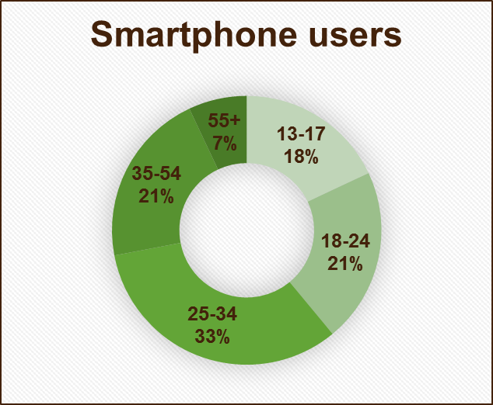

**Age**

**Group**

Our project is addressing a flourishing market; our intended customers are mainly English Fiction/crime novel readers from age 15 to 35.

Most of our target customers are in the cluster representing the intersection where the following users meet:

* Windows phone users (50 million users)
* Novel readers age 15 to 35 (more than 39% of readers)
* Goodreads users (20 million users)
* Fiction/Crime/YA genre fans (Revenue of books sold more than 1311.9 Million $)

## Current Market

After a detailed market research, the list came down to 3 projects that share some similarities with Rmagine, yet our project remains unique and we will demonstrate that below.

### https://metrouk2.files.wordpress.com/2013/06/ay_111573942.jpgIDinasour:

Figure 2- 2 Picture of IDinasour app

**Description:**

A phone app that detects QR codes in IDinasour books and generate pre-saved graphics in augmented reality.

**Features:**

* The user can control the model and animate it.
* The graphics of the application is very nice.

**Limitations:**

* The app does not do any text processing or NLP.
* It uses a limited set of pre-saved 3D models.
* The models are predefined for each page.

### NLP Story maker:



Figure 2- 3 Picture of NLP Story maker

**Description:**

A research project that was done by Microsoft Research to convert stories into graphics using a graphics library.

**Features:**

* The project is in the form of a Desktop application
* The text processing and NLP techniques in this project is solid and strong.
* The actors can be defined at the beginning of the story.

**Limitations:**

* The app use a pre-rendered graphic library to generate an animated scene for the current statement.
* It is only a research project.
* The user enters a story in the tool one sentence at a time

### WordsEye

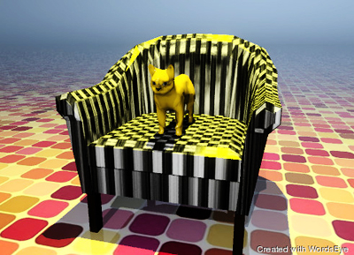

Figure 2- 4 Example of scenes generated using wordseye

**Description:**

WordsEye is a web and mobile application that allows you to Type a Picture by creating 3D scenes from a plain English description.

**Features:**

* Offers thousands of 3D models and 2D images for free use and premium content for purchase.
* You can personalize your scenes by uploading your own photos or importing them from Facebook.

**Limitations:**

* It uses pre-saved models.
* The plain text must be very descriptive.

## Our Unique Selling Proposal

**What we offer to our customers is as follow:**

* Visualization; whenever possible.
* Offering a comprehensive toolkit to enhance the reading experience.
* The app experience in augmented reality through VR glasses
* Fast, robust, real-time service using the cloud.



# **Necessary Background**

Chapter 3: Necessary Background

## Natural Language Processing

Natural language processing (NLP) is a field of computer science, artificial intelligence, and computational linguistics concerned with the interactions between computers and human (natural) languages. As such, NLP is related to the area of human–computer interaction. Many challenges in NLP involve natural language understanding, that is, enabling computers to derive meaning from human or natural language input, and others involve natural language generation.

## Parse Tree

A concrete syntax tree or parse tree or parsing tree or derivation tree is an ordered, rooted tree that represents the syntactic structure of a string according to some context-free grammar. Parse trees are usually constructed according to one of two competing relations, either in terms of the constituency relation of constituency grammars (= phrase structure grammars) or in terms of the dependency relation of dependency grammars. Parse trees are distinct from abstract syntax trees (also known simply as syntax trees), in that their structure and elements more concretely reflect the syntax of the input language. Parse trees may be generated for sentences in natural languages (see natural language processing), as well as during processing of computer languages, such as programming languages.

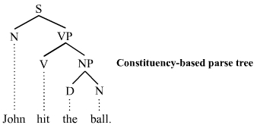The constituency-based parse trees of constituency grammars (= phrase structure grammars) distinguish between terminal and non-terminal nodes. The interior nodes are labeled by non-terminal categories of the grammar, while the leaf nodes are labeled by terminal categories.

Figure 3 - 1 Constituency-based parse tree example

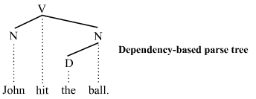The dependency-based parse trees of dependency grammars see all nodes as terminal, which means they do not acknowledge the distinction between terminal and non-terminal categories. They are simpler on average than constituency-based parse trees because they contain fewer nodes.

Figure 3 - 2 Dependency-based parse tree example

## Part-Of-Speech Tagging

In corpus linguistics, part-of-speech tagging (POS tagging or POST), also called grammatical tagging or word-category disambiguation, is the process of marking up a word in a text (corpus) as corresponding to a particular part of speech, based on both its definition, as well as its context—i.e. relationship with adjacent and related words in a phrase, sentence, or paragraph. A simplified form of this is commonly taught to school-age children, in the identification of words as nouns, verbs, adjectives, adverbs, etc.

Once performed by hand, POS tagging is now done in the context of computational linguistics, using algorithms, which associate discrete terms, as well as hidden parts of speech, in accordance with a set of descriptive tags. POS-tagging algorithms fall into two distinctive groups: rule-based and stochastic. E. Brill's tagger, one of the first and most widely used English POS-taggers, employs rule-based algorithms.

In part-of-speech tagging by computer, it is typical to distinguish from 50 to 150 separate parts of speech for English. For example, NN for singular common nouns, NNS for plural common nouns, NP for singular proper nouns (see the POS tags used in the Brown Corpus). Work on stochastic methods for tagging Koine Greek (DeRose 1990) has used over 1,000 parts of speech, and found that about as many words were ambiguous there as in English. A morph syntactic descriptor in the case of morphologically rich languages is commonly expressed using very short mnemonics, such as 'Ncmsan for Category=Noun, Type = common, Gender = masculine, Number = singular, Case = accusative, Animate = no.

## Lemma

In morphology and lexicography, a lemma (plural lemmas or lemmata) is the canonical form, dictionary form, or citation form of a set of words (headword)[citation needed]. In English, for example, run, runs, ran and running are forms of the same lexeme, with run as the lemma. Lexeme, in this context, refers to the set of all the forms that have the same meaning, and lemma refers to the particular form that is chosen by convention to represent the lexeme. In lexicography, this unit is usually also the citation form or headword by which it is indexed. Lemmas have special significance in highly inflected languages such as Arabic, Turkish and Russian. The process of determining the lemma for a given word is called lemmatization. The lemma can be viewed as the chief of the principal parts, although lemmatization is at least partly arbitrary.

## Object Detection

Object detection is a computer technology related to computer vision and image processing that deals with detecting instances of semantic objects of a certain class (such as humans, buildings, or cars) in digital images and videos. Well-researched domains of object detection include face detection and pedestrian detection. Object detection has applications in many areas of computer vision, including image retrieval and video surveillance.

Figure 3 - 3 Example of book detection.

## Object Recognition

Object recognition is the ability to perceive an object’s physical properties (such as shape, colour and texture) and apply semantic attributes to the object, which includes the understanding of its use, previous experience with the object and how it relates to others.

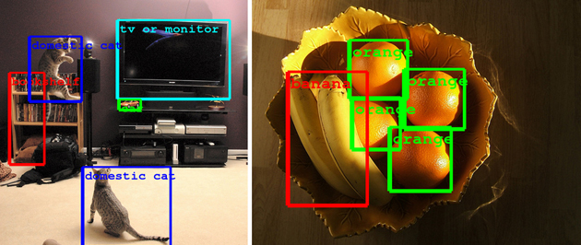

Figure 3 - 4 Example of object recognition

## Hough Transform

The Hough transform is a feature extraction technique used in image analysis, computer vision, and digital image processing. The purpose of the technique is to find imperfect instances of objects within a certain class of shapes by a voting procedure. The classical Hough transform was concerned with the identification of lines in the image, but later the Hough transform has been extended to identifying positions of arbitrary shapes, most commonly circles or ellipses.

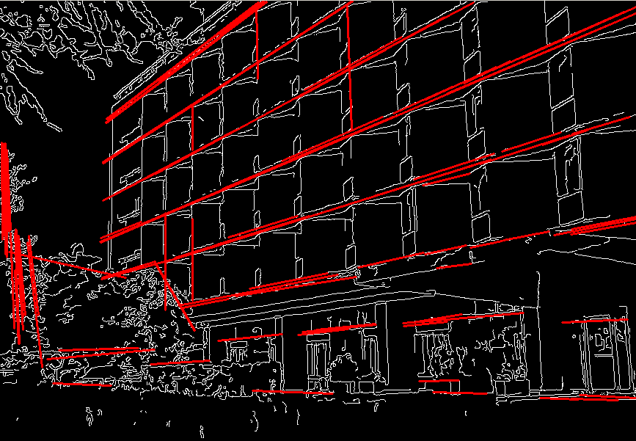

Figure 3 - 5 Example of hough transform



# **System Specifications**

Chapter 4: System Specifications

## System architecture Overview

### General Architecture

Figure 4 - 1 General architecture diagram

Server

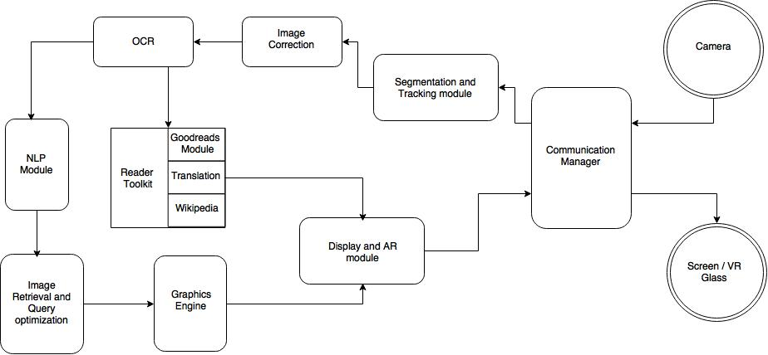

Client

### Working Environment

* Windows phone 8.1
* The smartphone must have a good camera with high quality.
* The internet connection must be stable and fast
* The book must be at a short distance (not to far) from the mobile all the time.

### Objectives

* Introducing an innovative approach to offer accurate graphical visualization of natural language text without preprocessing the text or using pre-saved models.
* Enhancing the reading experience of novel readers using everyday smartphones with offering the experience of a trending tool like the VR glasses.
* Producing a cross platform cloud based app that can be easily accessible to any kind of users offering a robust, fast and reliable service.
* Offering an attractive Reader Toolkit for users to enhance the reading experience for everyday readers.

### Main Functions

* The user can visualize Text
* Displaying output in VR mode
* User can get a book review from Goodreads
* User can translate a selected word
* User can search for a word in Wikipedia

## Use Cases

### Start Client-Server session

|  |  |
| --- | --- |
| Use Case ID | UC-1 |
| Use Case Name | Start Client Server Session |
| Actor | System |
| Trigger | Starting the app on Windows Phone 8.1 |
| Preconditions | * There is an established connection between the mobile and the server. * The server is running |
| Post-conditions | A session is started between the mobile (client) and the server. |
| Normal Flows | 1. The client send to the server HTTP request. 2. The server respond back confirming that the session established correctly |
| Alternative flows | None. |

Table 4 - 1 Use case 1

### Visualizing text

|  |  |
| --- | --- |
| Use Case ID | UC-2 |
| Use Case Name | Visualizing Text |
| Actor | User |
| Trigger | Detecting page with text |
| Preconditions | * A client server session is started * The camera is directed to a page with written text |
| Post-conditions | 2D drawing representing the text appear through augmented reality |
| Normal Flows | 1. The client send image to the server 2. The Segmentation and Tracking module detect the book and crop the page 3. The OCR extract the text from the page 4. NLP module read and understand the text to extract events 5. The Image retrieval and query optimization module search for the actors and objects in the web 6. Graphics engine generate the scene 7. The server send the scene as images to the client |
| Alternative flows | 1. The client send image to the server 2. The Segmentation and Tracking module can’t find a book 3. The server send to server empty request |

Table 4 - 2 Use case 2

### Starting VR Glass mode

|  |  |
| --- | --- |
| Use Case ID | UC-3 |
| Use Case Name | Starting VR glass mode |
| Actor | User |
| Trigger | Pressing “VR mode” button |
| Preconditions | * A client server session is started * The glass is directed to a page with written text |
| Post-conditions | Augmented reality mood is activated |
| Normal Flows | 1. The client send image to the server 2. The Segmentation and Tracking module detect the book and crop the page 3. The OCR extract the text from the page 4. NLP module read and understand the text to extract events 5. The Image retrieval and query optimization module search for the actors and objects in the web 6. Graphics engine generate the scene 7. The server send the scene as images to the client |
| Alternative flows | 1. The client send image to the server 2. The Segmentation and Tracking module can’t find a book. 3. The server send to server empty request |

Table 4 - 3 Use case 3

### Ratings and reviews

|  |  |
| --- | --- |
| Use Case ID | UC-4 |
| Use Case Name | Rating and reviews mode |
| Actor | User |
| Trigger | Pressing “Rating and reviews” button. |
| Preconditions | * A client server session is started * The camera is directed to a page with a cover page or a page with ISBN barcode |
| Post-conditions | Rating and reviews mode is activated |
| Normal Flows | 1. The client send image to the server 2. Reading toolkit read the barcode 3. Reading toolkit retrieve rating and review of the book from Goodreads 4. The server send review and rating image to the client |
| Alternative flows | 1. The client send image to the server 2. Reading toolkit can’t read the barcode 3. The server send empty request to the client |

Table 4 - 4 Use case 4

### Translation

|  |  |
| --- | --- |
| Use Case ID | UC-5 |
| Use Case Name | Translation mode |
| Actor | User |
| Trigger | Pressing “Translation” button |
| Preconditions | * A client server session is started * The camera is directed to a page with written text * The user touch the screen |
| Post-conditions | Translation mode is activated |
| Normal Flows | 1. The client send image to the server with touch coordinates 2. The Segmentation and Tracking module detect the book and crop the page 3. The OCR extract the text from the page with words coordinates 4. The Reader Toolkit map the word with the nearest coordinate to the touch coordinates 5. Translation module translate the word to the desired language 6. Display module display the translation through augmented reality |
| Alternative flows | 1. The client send image to the server with touch coordinates 2. The Segmentation and Tracking module can’t find the book 3. The server send empty request to the client |

Table 4 - 5 Use case 5

### Wikipedia Search

|  |  |
| --- | --- |
| Use Case ID | UC-6 |
| Use Case Name | Wikipedia Search mode |
| Actor | User |
| Trigger | Pressing “search” button |
| Preconditions | * A client server session is started * The camera is directed to a page with written text * The user touch the screen |
| Post-conditions | Wikipedia Search mode is activated |
| Normal Flows | 1. The client send image to the server with touch coordinates 2. The Segmentation and Tracking module detect the book and crop the page 3. The OCR extract the text from the page with words coordinates 4. The Reader Toolkit map the word with the nearest coordinate to the touch coordinates 5. Wikipedia module search Wikipedia.org for article related to word selected 6. Display module display the description part in Wikipedia article through augmented reality |
| Alternative flows | 1. The client send image to the server with touch coordinates 2. The Segmentation and Tracking module can’t find the book 3. The server send empty request to the client |

Table 4 - 6 Use case 6

## Dataflow Diagram

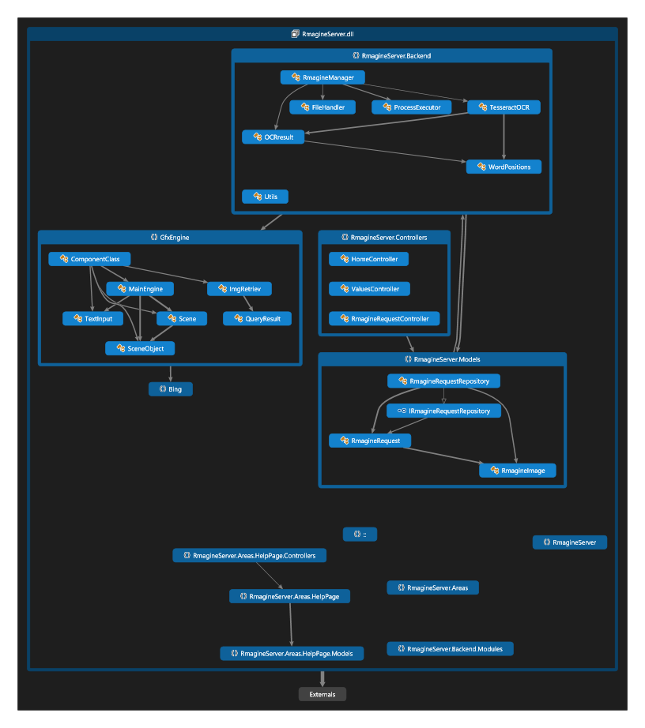

Figure 4 - 2 Dataflow diagram of Rmagine

## System Components

### Segmentation and detection module

**Description:**

The segmentation and detection module is responsible of detecting the image of the book coming from the smartphone camera and do segmentation on it to focus on the page the user is reading.

**Functionality:**

* Apply canny edge detection and detect book edges.
* Segment book using color segmentation.
* Apply Hough transform to extract lines of the page.
* Output a final cropped enhanced image of the page the user is reading.

**Class details:**

#### BookDetector

|  |  |
| --- | --- |
| Class Description | |
| The main class of the segmentation and detection module. | |
| Main Methods | |
| Mat segmentBook(Mat input) | Segment the book using color segmentation. |
| Mat removeNoise(Mat input, int morph_size) | Apply closing morphology transform, which is dilation of an image followed by erosion. |
| Mat CannyThreshold(Mat src_gray) | Apply Canny edge detection. |
| void drawLine(Mat img, Point start, Point end) | Draw line on an image from start to end points. |
| vector<Vec4i> extractLines(Mat input) | Apply Hough transform to extract all lines. |
| bool isHorizental(Vec4i line, float maxrotation = 0.1) | Check if line is horizontal with slope. |
| void getMaxLinesCoordinates(vector<Vec4i> lines, int& xmin, int& ymin, int& xmax, int& ymax) | Search for max and min coordinates of all lines. |
| Vector<LineSegmentsBlock*> findLineBlocks (verticalLineSegment* segments,int length, int max_spacing, int min_segments) | Find all blocks with horizontal text lines pattern. |
| Vec4i segmentLinesSequence(vector<Vec4i> lines, int max_spacing,int min_segements) | Segment line blocks by generating frequency map of lines. |
| Mat drawLines(Mat input, vector<Vec4i> lines) | Filter horizontal lines with slope. |
| void detectEdges(Mat edges) | Draw red lines on the given input image. |
| void hitmiss(cv::Mat& src, cv::Mat& dst, cv::Mat& kernel) | Detect book edges. |
| Mat extractBoundry(Mat input) | Apply hit-miss technique to find best parameters. |
| void filterCountours(vector<vector<Point> > contours) | Extract boundaries. |

Table 4 - 7 BookDetector class details

### OCR module

**Description:**

The Tesseract OCR module is responsible of understanding the images of the book pages and getting the text the app need to start processing. It.

**Functionality:**

* Read the book page image and extract the text inside it.

**Class diagram:**

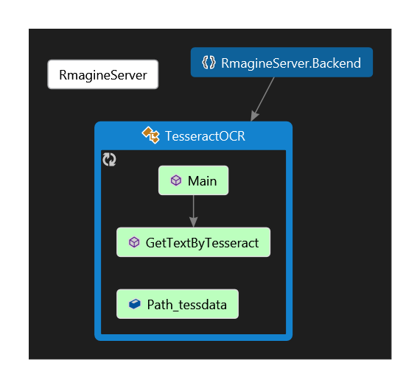

Figure 4 - 3 OCR class diagram

**Class details:**

#### TesseractOCR

|  |  |
| --- | --- |
| Class Description | |
| The main class of the OCR module. | |
| Main Methods | |
| OCRresult GetTextByTesseract(string ImagePath , string tessdataPath) | Take an image file path and extract the text inside the image and return it in a string. |

Table 4 - 8 TesseractOCR class details

### NLP Module

**Description:**

The NLP module is responsible of understanding the text and extracting nouns, verbs and prepositions from the text.

**Functionality:**

* Split the text to several events
* For each event generate parse tree and dependency graph
* Get nouns, verbs and prepositions from each parse tree
* Filter the directional prepositions from the prepositions
* Traverse dependency graph to get prepositions and verbs relations to the nouns.

**Class diagram:**

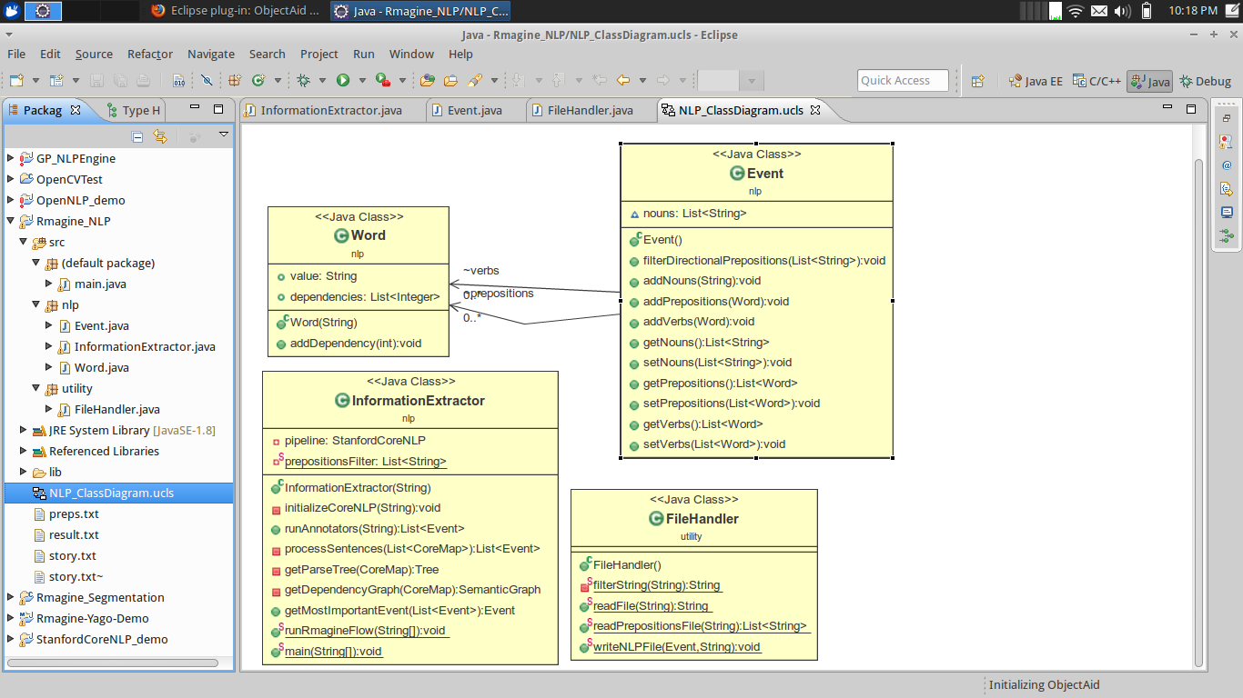

Figure 4 - 4 NLP class diagram

**Class details:**

#### InformationExtractor

|  |  |
| --- | --- |
| Class Description | |
| Extract information from text | |
| Main Methods | |
| InformationExtractor(String prepositionspath) | Constructor that read directional prepositions file |
| void initializeCoreNLP(String properties) | Initialize coreNLP class with pipeline properties |
| List<Event> runAnnotators(String text) | Process the text to split the words into sentences |
| List<Event> processSentences(List<CoreMap> sentences) | Generate events of each sentence with its nouns, verbs and prepositions then convert each noun to its lemma |
| Tree getParseTree(CoreMap sentence) | Generate parse tree for the sentence |
| SemanticGraph getDependencyGraph(CoreMap sentence) | Generate dependency graph for the sentence |

Table 4 - 9 InformationExtractor class details

#### Event

|  |  |
| --- | --- |
| Class Description | |
| Text Event that contain nouns and its relation with the verbs and prepositions | |
| Main Methods | |
| void filterDirectionalPrepositions(List<String> filter) | Filter only directional prepositions |
| void addNouns(String noun) | Add noun to the event |
| void addPrepositions(Word word) | Add preposition to the event |
| void addVerbs(Word word) | Add a verb to the event |
| List<String> getNouns() | Get nouns list |
| void setNouns(List<String> nouns) | Set nouns list |
| List<Word> getPrepositions() | Get prepositions list |
| void setPrepositions(List<Word> prepositions) | Set prepositions list |
| List<Word> getVerbs() | Get verbs list |
| void setVerbs(List<Word> verbs) | Set verbs list |

Table 4 - 10 Event class details

#### FileHandler

|  |  |
| --- | --- |
| Class Description | |
| Handle all files IO operations | |
| Main Methods | |
| String readFile(String path) | Read file and convert its content to string |
| List<String> readPrepositionsFile(String path) | Read directional prepositions file |
| void writeNLPFile(Event event, String path) | Write Graphics engine file |

Table 4 - 11 FileHandler class details

### Image Retrieval module

**Description:**

The Image retrieval module is responsible for searching for the keywords in each event to retrieve suitable images representing the scene objects of the final scene.

**Functionality:**

* Construct suitable search queries from the NLP output file to retrieve scene objects.
* Uses Bing Search API to search for these queries and collect results.
* Picks a relevant image from the search results and save it.
* Prepares the scene objects list used by the graphics engine.

**Class diagram:**

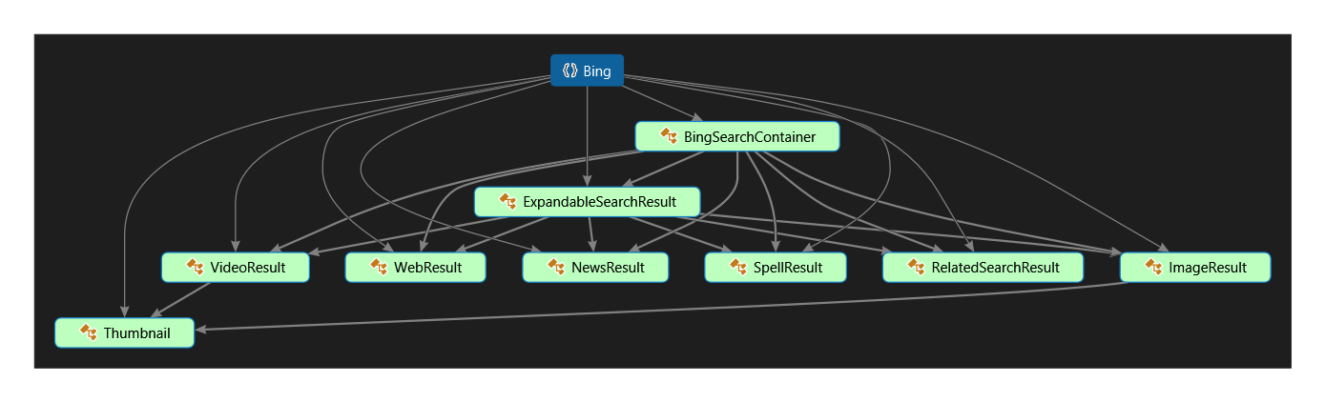

Figure 4 - 5 Bing search api class diagram

**Class details:**

#### ImgRetriev

|  |  |
| --- | --- |
| Class Description | |
| The main class of the image retrieval module. | |
| Main Methods | |
| ImgRetriev(string style, string color, string size, string keyword, int limit) | Construct a new ImgRetriev object by setting all the parameters needed to complete the search. |
| string ConstructFilter() | Construct the filter applied on the search query. |
| void Search() | Execute the query and search for images. |
| void Pick() | Pick a suitable result from the results list. |
| List<byte[]> DownloadImg() | Download the selected image. |

Table 4 - 12 ImgRetriev class details

#### TextInput

|  |  |
| --- | --- |
| Class Description | |
| Responsible of reading the text input and classifying it based on it’s type (nouns, verbs, prepositions) | |
| Main Methods | |
| void Readfile(string filepath) | Read the output of the NLP module from file. |

Table 4 - 13 TextInput class details

### Graphics engine module

**Description:**

The graphics engine is responsible for resizing and positioning the scene objects to be displayed in the final scene.

**Functionality:**

* Resize object based on categories and prior knowledge.
* Position object based on default positions and prior knowledge.
* Organize objects in final scene using spatial relations represented in a scene graph.
* Prepare final output to be passed to the Display module.

**Class diagram:**

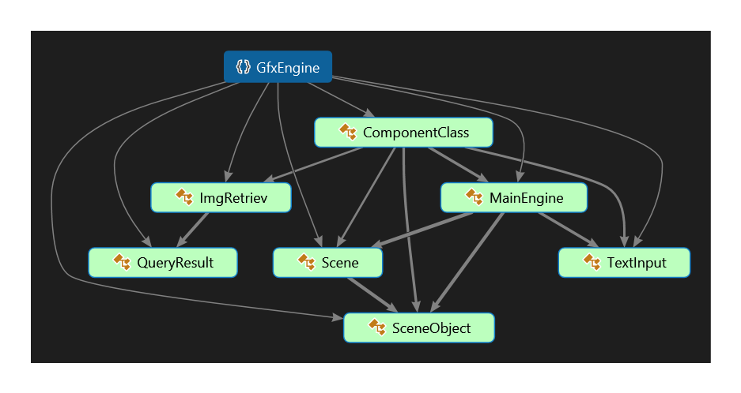

Figure 4 - 6 Graphics engine class diagram

**Class details:**

#### MainEngine

|  |  |
| --- | --- |
| Class Description | |
| Responsible of reading the prior knowledge files and initializing the final scene. | |
| Main Methods | |
| void getSize(int i) | Assign an initial size to object “i” in the Scene objects list based on the prior knowledge files. |
| void getPosition(int i) | Assign an initial position to object “i” in the Scene objects list based on the prior knowledge files. |
| MainEngine(List<SceneObject> ImageList, TextInput Input, Tuple<int, int> gridSize) | Read prior knowledge files and save them to be used in positioning and sizing, and initialize the final scene object. |

Table 4 - 14 MainEngine class details

#### Scene

|  |  |
| --- | --- |
| Class Description | |
| Responsible of handling all scene components and creating the scene graph. | |
| Main Methods | |
| public Scene(List<SceneObject> ImageList, Tuple<int, int> gSize) | Construct a new scene of size gSize that contains ImageList objects. |
| public void Refine_usingSceneGraph(TextInput myInput) | Create scene graph based on spatial relations. |

Table 4 - 15 Scene class details

#### SceneObject

|  |  |
| --- | --- |
| -Class Description | |
| Responsible of handling all scene object attributes inside the scene. | |
| Main Methods | |
| SceneObject(byte[] byteArray) | Construct a new scene object from byte array. |
| void ResizeImg() | Resize a bitmap image of the Scene object. |

Table 4 - 16 SceneObject class details

### Reader toolkit modules

#### Goodreads module

**Description:**

The goodreads module is responsible of getting the reviews and ratings of a book given it’s ISBN or title.

**Functionality:**

* .Get book ratings and reviews from Goodreads given book title and book author.
* Get book ratings and reviews from Goodreads given ISBN.

**Class details:**

#### APIgoodReads

|  |  |
| --- | --- |
| Class Description | |
| The main class of the Goodreads module and responsible of communication and retrieving results. | |
| Main Methods | |
| int review_star(string review_rating) | Get the rating in the form of stars for a certain review. |
| string GetGoodreadsURI(string bookAuthor, string bookTitle) | Construct the uri of goodreads from bookAuthor, bookTitle and key api. |
| string GetGoodreadsURIbyISBN(string ISBN) | Construct the uri of goodreads from ISBN and key api. |
| List<string> parseXML(XmlDocument doc) | Parse the xml of a given xml document. |
| private string GetUrlreviews(string reviews_widget) | Extract the url of the reviews from the parsed xml. |
| string GetHTMLOfURL(string url) | Get the HTML of a given url of a review. |
| string GetBookShelf(string t, string a) | Send HTTP request to Goodreads with the book title and author to get book. |
| string GetBookByISBN(string ISBN) | Sends HTTP request to Goodreads with the ISBN to get book. |

Table 4 - 17 APIGoodReads class details

#### Translation module

**Description:**

The translation module is responsible of translating a given text from English to a given language.

**Functionality:**

* Translate a given text to a given language using Microsoft Translator.

**Class details:**

#### Translator

|  |  |
| --- | --- |
| Class Description | |
| The main class of the translator. Responsible of requesting a required translation from the api. | |
| Main Methods | |
| string translate(String outLanguage, string text, string inlanguage) | Sends HTTTP request to translate a string text to an OutLanguage. |

Table 4 - 18 Translator class details

#### Wikipedia module

**Description:**

The Wikipedia module is responsible of search for a given word on Wikipedia and getting information about it.

**Functionality:**

* Get text of Wikipedia page of a given word.

**Class details:**

#### ConsoleAppgetWiki

|  |  |
| --- | --- |
| Class Description | |
| The main class of Wikipedia. Responsible of getting information about a word from the API. | |
| Main Methods | |
| string GetStream(string query1) | Sends HTTTP request to get information from Wikipedia about a given word. |

Table 4 - 19 ConsoleAPPGetWiki class details

### Display and Virtual Reality module

**Description:**

The display and virtual reality module is responsible of preparing the output of each module for display and send images ready to be displayed to the client.

**Functionality:**

* Prepare the output of Goodreads for display
* Prepare the output of the translator for display
* Prepare the output of the Wikipedia for display

**Class details:**

#### Display

|  |  |
| --- | --- |
| Class Description | |
| This is the main class of the display module. | |
| Main Methods | |
| public Bitmap CreateReviewWithRating(float Rate, string review, int H, int W, int F, int Background_R, int Background_G, int Background_B, int Brush_R, int Brush_G, int Brush_B) | Prepare an image to be displayed representing the Review and the rating. |
| public Bitmap CreateTranslation(string language, string txt, int H, int W, int F, int Background_R, int Background_G, int Background_B, int Brush_R, int Brush_G, int Brush_B) | Prepare an image to be displayed representing the Translation . |
| public Bitmap CreateWiki(string Title, string txt, int H, int W, int F, int Background_R, int Background_G, int Background_B, int Brush_R, int Brush_G, int Brush_B) | Prepare an image to be displayed representing the output of the Wikipedia search. |
| public Bitmap CreateAvgRating(float Rate) | Prepare an image to be displayed representing the average goodreads rating. |

Table 4 - 20 Display class details

### Communication manager module (Server)

**Description:**

The communication manager module responsible for communicating with the clients and with modules with each other

**Functionality:**

* Retrieve images from clients
* detect and read text from pages and generate graphics representing the text in it
* Send the graphics to the client

**Class diagram:**

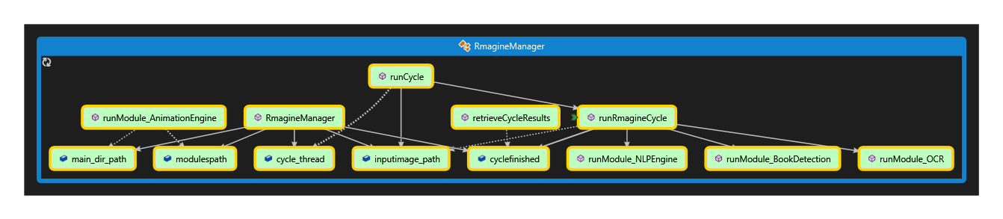

Figure 4 - 7 Rmagine manager class diagram

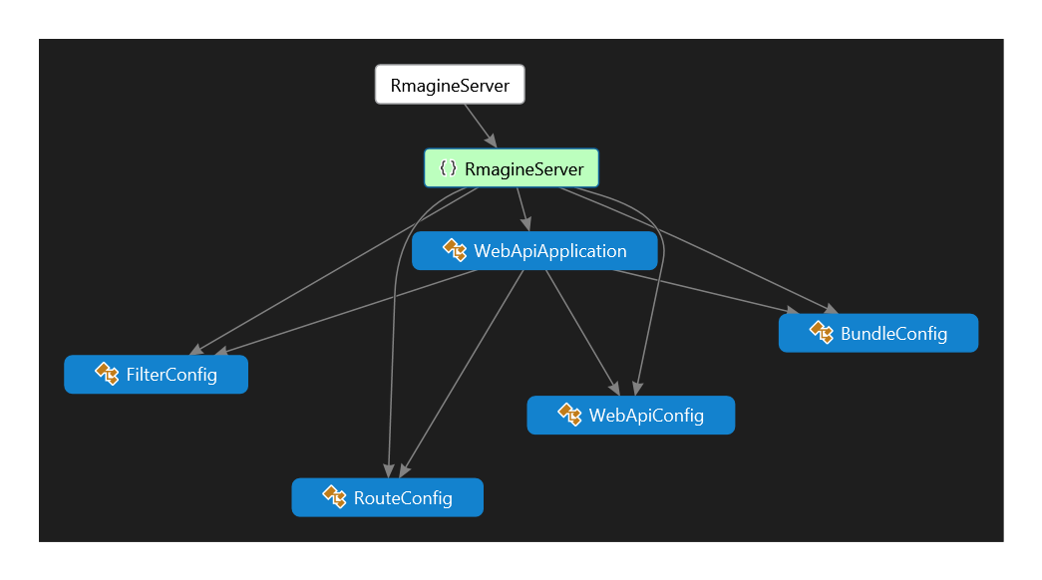

Figure 4 - 8 Rmagine server class diagram

**Class details:**

#### RmagineRequest

|  |  |
| --- | --- |
| Class Description | |
| Request to send through HTTP | |
| Main Methods | |
| public RmagineRequest(string type) | Type of the request |
| public void addRImage(RmagineImage img) | Add image to the request |
| public void addRImage(int x, int y, int h, int w, byte[] img, bool animation) | Add image to the request |

Table 4 - 21 RmagineRequest class details

#### RmagineImage

|  |  |
| --- | --- |
| Class Description | |
| Image container with its coordinates and dimensions to be visualized on the target client | |
| Main Methods | |
| RmagineImage(int x, int y, int h, int w, byte[] img, bool animation) | Constructing object from RmagineImage |
| byte[] convertToBytes(Bitmap bitmapImage) | convert Bitmap image to bytes array |
| Bitmap convertToBitmap(byte[] byteArray) | Convet bytes array to Bitmap image |

Table 4 - 22 RmagineImage class details

#### RmagineRequestRepository

|  |  |
| --- | --- |
| Class Description | |
| Handle HTTP Post and Get requests | |
| Main Methods | |
| RmagineRequestRepository() | Construct connection |
| RmagineRequest Get() | Handle Get requests |
| RmagineRequest Send(RmagineRequest request) | Handle Post requests |

Table 4 - 23 RmagineRequestRepository class details

#### ProcessExecutor

|  |  |
| --- | --- |
| Class Description | |
| To execute exe and jar files in a process | |
| Main Methods | |
| ProcessStartInfo initializeProcessInfo(string filename) | Initialize process info and running modes |
| void startProcess(string filename, string[] args) | Start process with args |
| viewImage(string path) | View image using default system image viewer |
| string scanQR(string imagepath) | Run QR software to read QR code |
| void runBatFile(string target) | Run batch file |

Table 4 - 24 Process Executor class details

#### RmagineManager

|  |  |
| --- | --- |
| Class Description | |
| Manage Rmagine modules running cycles | |
| Main Methods | |
| RmagineManager() | Initialize RmagineManager |
| void runModule_BookDetection(string exe_path, string input, string cropped, string info) | Run book detection modul e |
| void runModule_NLPEngine(string script_path) | Run NLP module |
| string runModule_AnimationEngine(string[] args) | Run Animation detection engine |
| void runModule_OCR(string image_path,string data_path,string result_path) | Run OCR module |
| void runRmagineCycle() | Run all modules cycles |
| void runCycle(string inputimg_path) | Run cycle in thread |
| List<SceneObject> retrieveCycleResults() | Get cycle result |

Table 4 - 25 RmagineManager class details



# **Tools**

Chapter 5: Tools

## OpenCV



Figure 5 - 1 OpenCV logo

OpenCV is released under a BSD license and hence it’s free for both academic and commercial use. It has C++, C, Python and Java interfaces and supports Windows, Linux, Mac OS, iOS and Android. OpenCV was designed for computational efficiency and with a strong focus on real-time applications. Written in optimized C/C++, the library can take advantage of multi-core processing. Enabled with OpenCL, it can take advantage of the hardware acceleration of the underlying heterogeneous compute platform. Adopted all around the world, OpenCV has more than 47 thousand people of user community and estimated number of downloads exceeding 9 million. Usage ranges from interactive art, to mines inspection, stitching maps on the web or through advanced robotics.

## Microsoft .NET framework 4.5



Figure 5 - 2 .Net logo

The .NET Framework is a technology that supports building and running the next generation of applications and XML Web services. The .NET Framework is designed to fulfill the following objectives:

* To provide a consistent object-oriented programming environment whether object code is stored and executed locally, executed locally but Internet-distributed, or executed remotely.
* To provide a code-execution environment that minimizes software deployment and versioning conflicts.
* To provide a code-execution environment that promotes safe execution of code, including code created by an unknown or semi-trusted third party.
* To provide a code-execution environment that eliminates the performance problems of scripted or interpreted environments.
* To make the developer experience consistent across widely varying types of applications, such as Windows-based applications and Web-based applications.
* To build all communication on industry standards to ensure that code based on the .NET Framework can integrate with any other code.

The .NET Framework consists of the common language runtime and the .NET Framework class library. The common language runtime is the foundation of the .NET Framework. The class library is a comprehensive, object-oriented collection of reusable types that you can use to develop applications ranging from traditional command-line or graphical user interface (GUI) applications to applications based on the latest innovations provided by ASP.NET, such as Web Forms and XML Web services.

The following illustration shows the relationship of the common language runtime and the class library to your applications and to the overall system. The illustration also shows how managed code operates within a larger architecture.

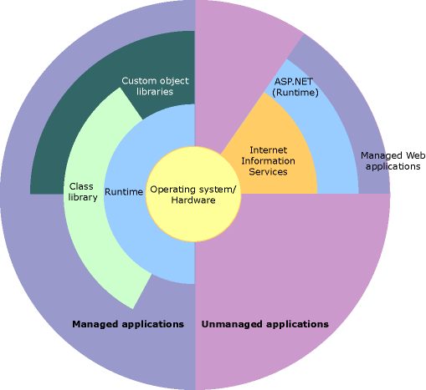  
.NET Framework in context

Figure 5 - 3 .Net Framework architecture

## Microsoft Visual Studio 2013



Figure 5 - 4 Visual Studio logo

Microsoft Visual Studio is an integrated development environment (IDE) from Microsoft. It is used to develop computer programs for Microsoft Windows, as well as web sites, web applications and web services. Visual Studio uses Microsoft software development platforms such as Windows API, Windows Forms, Windows Presentation Foundation, Windows Store and Microsoft Silverlight. It can produce both native code and managed code.

Visual Studio includes a code editor supporting IntelliSense (the code completion component) as well as code refactoring. The integrated debugger works as both a source-level debugger and a machine-level debugger. Other built-in tools include a forms designer for building GUI applications, web designer, class designer, and database schema designer. It accepts plug-ins that enhance the functionality at almost every level—including adding support for source-control systems (like Subversion) and adding new toolsets like editors and visual designers for domain-specific languages or toolsets for other aspects of the software development lifecycle (like the Team Foundation Server client: Team Explorer).

Visual Studio supports different programming languages and allows the code editor and debugger to support (to varying degrees) nearly any programming language, provided a language-specific service exists. Built-in languages include C, C++ and C++/CLI (via Visual C++), VB.NET (via Visual Basic .NET), C# (via Visual C#), and F# (as of Visual Studio 2010). Support for other languages such as M, Python, and Ruby among others is available via language services installed separately. It also supports XML/XSLT, HTML/XHTML, JavaScript and CSS. Java (and J#) were supported in the past.

## Microsoft Azure Services



Figure 5 - 5 Microsoft Azure logo

The Azure™ Services Platform (Azure) is an internet-scale cloud services platform hosted in Microsoft data centers, which provides an operating system and a set of developer services that can be used individually or together. Azure’s flexible and interoperable platform can be used to build new applications to run from the cloud or enhance existing applications with cloud-based capabilities. Its open architecture gives developers the choice to build web applications, applications running on connected devices, PCs, servers, or hybrid solutions offering the best of online and on-premises.

Azure reduces the need for up-front technology purchases, and it enables developers to quickly and easily create applications running in the cloud by using their existing skills with the Microsoft Visual Studio development environment and the Microsoft .NET Framework. In addition to managed code languages supported by .NET, Azure will support more programming languages and development environments in the near future. Azure simplifies maintaining and operating applications by providing on-demand compute and storage to host, scale, and manage web and connected applications. Infrastructure management is automated with a platform that is designed for high availability and dynamic scaling to match usage needs with the option of a pay-as-you-go pricing model. Azure provides an open, standards-based and interoperable environment with support for multiple internet protocols, including HTTP, REST, SOAP, and XML.

## Tesseract OCR

Tesseract is an optical character recognition engine for various operating systems. It is free software, released under the Apache License, Version 2.0, and Google has sponsored development since 2006. Tesseract is considered one of the most accurate open source OCR engines currently available.

## Stanford corenlp

Stanford CoreNLP provides a set of natural language analysis tools which can take raw text input and give the base forms of words, their parts of speech, whether they are names of companies, people, etc., normalize dates, times, and numeric quantities, and mark up the structure of sentences in terms of phrases and word dependencies, indicate which noun phrases refer to the same entities, indicate sentiment, etc. Stanford CoreNLP is an integrated framework. Its goal is to make it very easy to apply a bunch of linguistic analysis tools to a piece of text. Starting from plain text, you can run all the tools on it with just two lines of code. It is designed to be highly flexible and extensible. With a single option you can change which tools should be enabled and which should be disabled. Its analyses provide the foundational building blocks for higher-level and domain-specific text understanding applications.

Figure 5 - 6 Stanford NLP logo

Stanford CoreNLP integrates many of our NLP tools, including the part-of-speech (POS) tagger, the named entity recognizer (NER), the parser, the coreference resolution system, the sentiment analysis, and the bootstrapped pattern learning tools. The basic distribution provides model files for the analysis of English, but the engine is compatible with models for other languages. Below you can find packaged models for Chinese and Spanish, and Stanford NLP models for German and Arabic are usable inside CoreNLP.

Stanford CoreNLP is written in Java and licensed under the GNU General Public License (v3 or later; in general Stanford NLP code is GPL v2+, but CoreNLP uses several Apache-licensed libraries, and so the composite is v3+). Source is included. Note that this is the full GPL, which allows many free uses, but not its use in proprietary software which is distributed to others. The download is 260 MB and requires Java 1.8+.

## Goodreads api



Figure 5 - 7 Goodreads logo

The Goodreads API allows developers access to Goodreads data in order to help websites or applications that deal with books be more personalized, social, and engaging. The API can be used in many ways, including:

**Review Syndication:** Goodreads has 10 million reviews across 700,000 titles - one of the largest and deepest collection of quality book reviews on the internet. Our API makes it easy to display these reviews on your website. Learn more about the Review Partner Program.

**Goodreads Connect:** Let members connect to their Goodreads accounts, and you'll have full access to the books in their shelves, their ratings, their reviews, and their friends – the social reading graph. Use this to personalize an ecommerce store, power recommendations, show a widget of a member's favorite books, build a mobile or desktop client app, and more. Learn more about Goodreads Connect.

## Bing search api

The Bing Search API enables developers to embed search results in applications or websites using XML or JSON. Add search functionality to a website, create unique consumer or enterprise apps, or develop new mash-ups.

The Bing Search API offers multiple source types (or types of search results). You can request a single source type or multiple source types with each query. For instance, you can request web, images, news, and video results for a single search query. The Bing Search API returns results for the following source types:

Web, Images, News, Videos, Related Search (Related search suggestions based on the query entered), and Spelling Suggestions (Spelling suggestions based on the query entered).

## Microsoft Translator API

Microsoft Translator API is a cloud-based automatic translation (aka machine translation) service supporting multiple languages that reach more than 95% of world gross domestic product (GDP). Translator can be used to build applications, websites, and tools, or any solution requiring Multilanguage support.

Built for business, Microsoft Translator is a proven, customizable, and scalable solution for automatic translation. Microsoft Translator technology powers translation features across all Microsoft products, including Office, SharePoint, Lync, Yammer, Visual Studio, Bing, and Skype. You can integrate translation into web, desktop, or mobile applications, the Translator API provides a rich functionality set for any developer, not to mention a wide choice of interfaces: AJAX, HTTP, SOAP, OData, and the Translator Web Widget.

## Durovis Dive VR Glass

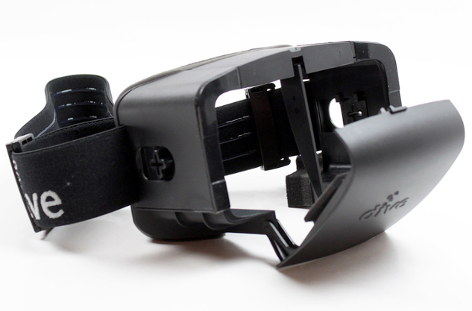Dive is the original VR headset for mobile devices. It is a rugged nylon viewer for mobile devices featuring two adjustable lenses which project an image of the virtual scene into each eye. Using it, you experience a stereoscopic view that spans most of the visual field. Combined with Dive head-tracking software, this creates a fast and responsive VR experience using the gyroscope sensors of the device. In addition, Dive offers a magnetic switch for click input which is fully compatible with both Dive and Cardboard apps.

Figure 5 - 8 Picture of Durovis glass



# **Test Plan**

Chapter 6: Test Plan

## Introduction

This chapter provides an overview of Rmagine testing strategy. The objectives are to ensure that the features mentioned for Rmagine is met and functions well. Unit, integration, system and acceptance tests were applied to different parts of our system. Tests were performed on a smartphone running on windows phone 8.1 (Nokia Lumia 820).

### Objectives

The objective of Rmagine test plan is to find and report any bugs of the system to provide integrity and improve it for the users of our system. The main objective of testing is to ensure that the system is performing its main functionalities and also integration of the main modules of Rmagine is tested to satisfy the system integrity.

### Testing Strategy

This section outlines the types of testing that was made for unit, integration, system and acceptance testing. It also includes what features, functionalities that was tested and the specific use cases that determine how the testing is done. Also it includes steps and results of testing RMagine with real users and their feedback.

## Features to Be Tested

**Unit testing**

1. Start text visualization
2. Start VR mode glass
3. Get Ratings & reviews
4. Get translation
5. Wiki Search

**Integration testing**

1. Start session between server and client
2. Request and receive packages from server

## Approach

This section describes the overall approach used to test Rmagine and the results of testing, also the schedule followed to perform our testing plan.

### Unit (component) Testing

To test the source code of the system for logical errors, interface errors, behavior errors, and initialization and termination errors of our system. It is designed to test the validity of the software’s correctness. Black box testing is the technique chose for this level of testing. Black box testing looks at the system as the end user without knowing any details of the inside functions. Just put inputs and test its outputs.

### Integration Testing

This level of testing is to expose the faults in the interaction between server and client and all the rest of the modules. Hybrid is the approach used in integration testing level, first we tested the integration of the communication manager and the rest of the modules then we added all to the server and tested again.

### System Testing

Test the whole system after integration to ensure that the function validity of the system and its performance are met. Black box testing is used in this level of testing.

* + 1. System response to inputs and commands
    2. System reliability and error handling

### Functional validation:

Test the system to ensure that the right system is built to address the functional requirements mentioned in chapter 4.

## Recovery Testing

This level of testing is performed to test how the system operates after crashing and test the server for the last operations performed before crashing.

## Testing schedule



Figure 6 - 1 Picture of Testing schedule

## Test cases

### Start text visualization

|  |  |
| --- | --- |
| Test case # | TC-1 |
| Test type | Unit testing |
| Test case name | Start text visualization |
| Purpose | Test if the visualize text mode is working correctly. |
| Prerequisites | * A client server session is started * The camera is directed to a page with written text |
| Steps | * Connect to the internet * Start the app * Point the smartphone camera to a book page with text. |
| Expected results | 2D drawing representing the text appear through augmented reality |
| Actual results | 2D drawing representing the text appear through augmented reality |
| State | Pass. |

Table 6 - 1 Start text visualization test case

### Start VR mode glass

|  |  |
| --- | --- |
| Test case # | TC-2 |
| Test type | Unit testing |
| Test case name | Start VR mode glass |
| Purpose | Test if the VR mode starts correctly. |
| Prerequisites | * A client server session is started * The glass is directed to a page with written text |
| Steps | 1. Connect to the internet 2. Start the app 3. Click on VR mode button in the menu 4. Point the smartphone camera to a book page with text. |
| Expected results | Augmented reality mood is activated |
| Actual results | Augmented reality mood is activated |
| State | Pass. |

Table 6 - 2 Start VR mode glass test case

### Get Ratings & reviews

|  |  |
| --- | --- |
| Test case # | TC-3 |
| Test type | Unit testing |
| Test case name | Get Ratings & reviews |
| Purpose | Test if the app can retrieve the ratings and reviews of the book. |
| Prerequisites | * A client server session is started * The glass is directed to a page with written text |
| Steps | 1. Connect to the internet 2. Start the app 3. Click on Get ratings button in the menu 4. Point the smartphone camera to the barcode/ ISBN of the book. |
| Expected results | 1. Rating and reviews mode is activated 2. Rating and reviews are displayed on the screen. |
| Actual results | 1. Rating and reviews mode is activated 2. Rating and reviews are displayed on the screen. |
| State | Pass. |

Table 6 - 3 Get Ratings & reviews test case

### Get translation

|  |  |
| --- | --- |
| Test case # | TC-4 |
| Test type | Unit testing |
| Test case name | Get translation |
| Purpose | Test if the app can translate a selected word from the book. |
| Prerequisites | * A client server session is started * The glass is directed to a page with written text |
| Steps | 1. Connect to the internet 2. Start the app 3. Click on Translate button in the menu 4. Click on the word you wish to translate. 5. Select translation language |
| Expected results | 1. Translate mode is activated 2. Translation is displayed on the screen. |
| Actual results | 1. Translate mode is activated 2. Translation is displayed on the screen. |
| State | Pass. |

Table 6 - 4 Get translation test case

### Wiki Search

|  |  |
| --- | --- |
| Test case # | TC-5 |
| Test type | Unit testing |
| Test case name | Wiki search |
| Purpose | Test if the app can translate a selected word from the book. |
| Prerequisites | * A client server session is started * The glass is directed to a page with written text |
| Steps | 1. Connect to the internet 2. Start the app 3. Click on Wiki search button in the menu 4. Click on the word you wish to search Wikipedia about. |
| Expected results | 1. Wiki search mode is activated 2. Wikipedia information is displayed on the screen. |
| Actual results | 1. Wiki search mode is activated 2. Wikipedia information is displayed on the screen. |
| State | Pass. |

Table 6 - 5 Wiki Search test case

### Start session between server and client

|  |  |
| --- | --- |
| Test case # | TC-6 |
| Test type | Integration testing |
| Test case name | Start session between server and client |
| Purpose | Test the connection protocols. |
| Prerequisites | * There is an established connection between the mobile and the server. * The server is running |
| Steps | Start the app on Windows Phone 8.1 |
| Expected results | A session is started between the mobile (client) and the server. |
| Actual results | A session is started between the mobile (client) and the server. |
| State | Pass. |

Table 6 - 6 Start session between server and client test case



# **Conclusion and Future Work**

Chapter 7: Conclusion and Future work

## Conclusion

Text to scene Conversion is one of the topics researchers are investing in these days because of it’s numerous possible application and to utilize the fact that natural language is an easy and effective medium for describing visual ideas and mental images.

Our project took books as an example to natural text and worked on producing visualizations to the events and actions between the lines. The project’s model is a client-server model, and our client is windows phone 8.1 and the server is on the cloud. We used a readymade OCR to input the text of the paper books and after processing this input, the output is displayed in augmented reality through VR glasses or on the smartphone screen. The reader toolkit was added to complement the project with some popular tools and features any reader will likely find them useful while reading.

We started with detecting the page using the segmentation and detection module. We then passed the detected image to the OCR module then to the NLP module. The NLP module did proper segmentation of the page into a series of events, and then it extracted all the objects/actors of interest. It also extracted all the spatial relations and verbs related to these objects. The graphics engine then retrieved the images and prepared all the attributes of the scene components. All of the mentioned is done on the server side the display module then communicate to the client displaying outputs. The reader toolkit is activated through buttons as demonstrated in the previous chapters, and all of the functions it does are straight forward using the APIs we mentioned.

The resulted app is a unique product that will be prepared during the next period to be launched in the real market. During our work to produce the first version of Rmagine, we discovered more techniques that could be implemented in the future to make our system more robust and much more accurate. Techniques are for example but not limited, using ontologies to get a better understanding of the text. Using a more complicated scene graph and an advanced model to complete missing scene information, learning from existing scene and images to increase the prior knowledge. We are also planning to invest more in the user experience to enhance our app and make it ready for the market.

## Future Work

### Advanced Text Processing and understanding

Further understanding of the processed text will help us achieve better results. After researching, we came down to some techniques that we plan to add in the future.

First, using ontologies can provide extra information about the object and can provide us with multiple attributes. A machine-readable ontology is a sophisticated version of a semantic net, in which concepts are identified with nodes and relationships between concepts are identified as linkage. Semantic nets are sufficient to understand a class of well-formed text where semantics is about very static situations.

Second, we will use WordNet to help us in categorizing and grouping the English nouns, verbs, and adjectives. WordNet is a large lexical database of English. Nouns, verbs, adjectives and adverbs are grouped into sets of cognitive synonyms (synsets), each expressing a distinct concept. Synsets are interlinked by means of conceptual-semantic and lexical relations. By using WordNet the words will be categorized and grouped and this will help us scope down things to be able to provide a better representation of text.

### Complex scene templates and graphs

Scene graphs can be optimized and extended to not only handle spatial relations between object, but also deduce missing objects in scenes as well. We have read about researches done in this field that lead to impressive results and adding this to our project will be a valuable addition. We will not only express the text we have but also we will be creating a very similar image to the image our mind can produce given a certain text.

### Prior knowledge learning agents

To offer real-time visualizations without pre-saved models, we have to have a solid prior knowledge so our engine can be smart enough to output logical illustrations. Scene templates and scene graphs also require a lot of prior knowledge to be able to produce accurate and acceptable results. We want to implement some learning agents to learn more about the various objects in the scene, and to construct more scene templates. The agents will be able to learn sizes and position of objects also learn about how the objects can relate in one scene. Further learning can be done to be able to represent verbs and actions as well in an accurate manner.

### 3D scenes

We want to support 3d scene generation and not only 2d. This will require a big upgrade in the graphics engine component and some optimizations to handle the extra processing needed.

### Gesture recognition

We want to support gestures. This will give the reader the full experience with augmented reality, because he will be able to use all of the features and the reader toolkit through gestures and with no need of any buttons.

### Further Goodreads integration

We would like to add more features related to Goodreads, like adding books to shelves and updating your reading progress. This will be available for our users using OCR and augmented reality so it will be an attractive feature for readers and will make it easy to connect with other readers.

# **References**

* <http://citeseerx.ist.psu.edu/viewdoc/download?doi=10.1.1.50.9053&rep=rep1&type=pdf>
* <http://www.aaai.org/Papers/AAAI/1994/AAAI94-118.pdf>
* <http://www.cs.utah.edu/~riloff/pdfs/ashwin-chapter.pdf>
* <http://131.107.65.14/pubs/69486/NLP_Story_Maker_Final.pdf>
* <http://dl.acm.org/citation.cfm?id=383316>
* [https://**wordnet**.princeton.edu/](https://wordnet.princeton.edu/)
* <http://sw.opencyc.org/>
* <http://papers.nips.cc/paper/5207-deep-neural-networks-for-object-detection.pdf>
* <http://www.aaai.org/Papers/AAAI/2000/AAAI00-069.pdf>
* htttp://www.bing.com
* htttp://www.wikipedia.com
* htttp://www.goodreads.com



# **Appendix-A: User Manual/Guide**

## .A.1. Prerequisites

To use our App user will need first to have four components:

* Windows phone 8.1
* VR Glasses [optional]
* Connection to internet
* A novel (a paper book)

## A.2. The Rmagine guide

### A.2.1. starting the app:

* Install the app to your phone and open it.

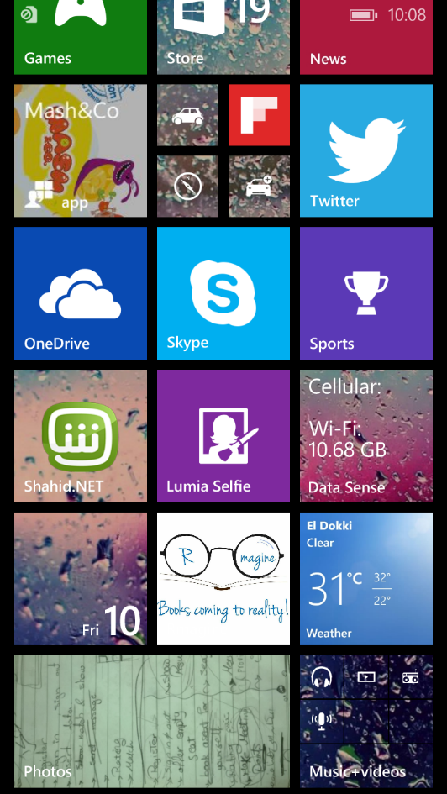

**Click Here**

Figure A - 1 Picture of Windows phone 8.1 main screen

* If app not connected to internet the red warning sign will appear in the corner of the screen

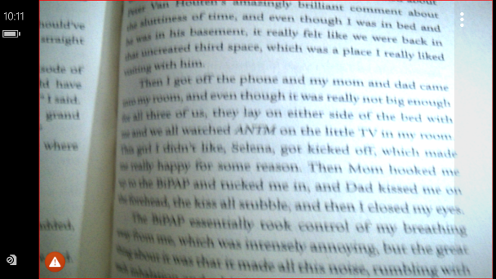

Figure A - 2 Connection error screenshot

* The app by default starts in the “**Visualize text**” mood.

### A.2.2. Navigating through the menu:

* To display the menu of the app click on the three white dots appearing at the side bar.

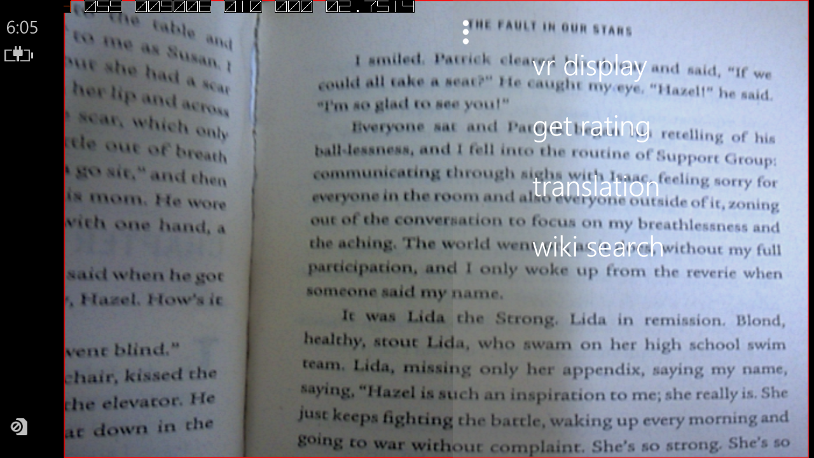

Figure A - 3 Opening menu screenshot

* To switch to Virtual reality mode click on VR display in menu

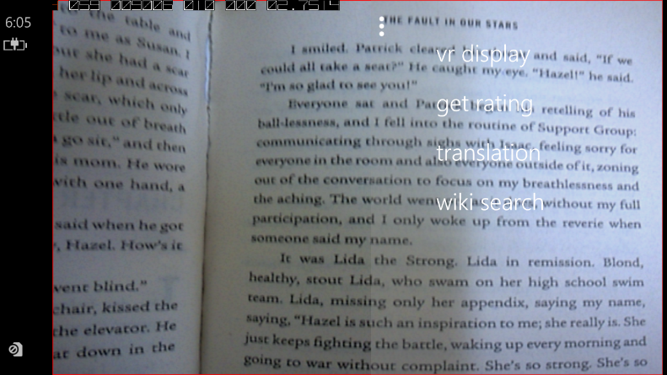

Figure A - 4 Select VR mode

* Place your phone inside the VR glass as shown in the figures below

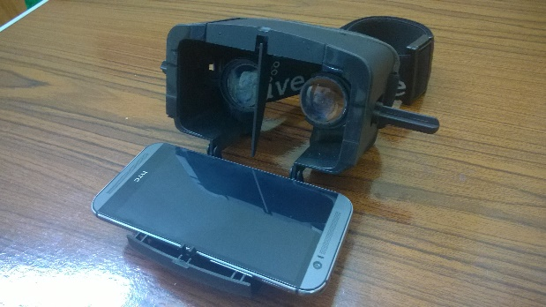

Figure A - 5 Open VR glasses

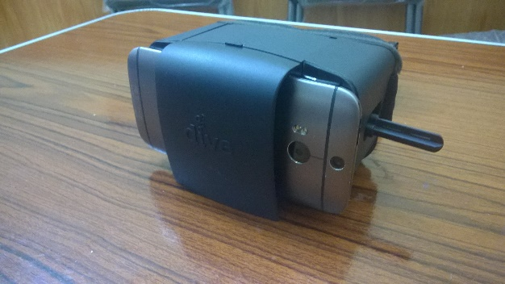

Figure A - 6 Mobile in VR glasses

* The picture displayed will be as the figure below.
* Enjoy visualizing your favorite scenes in virtual reality.

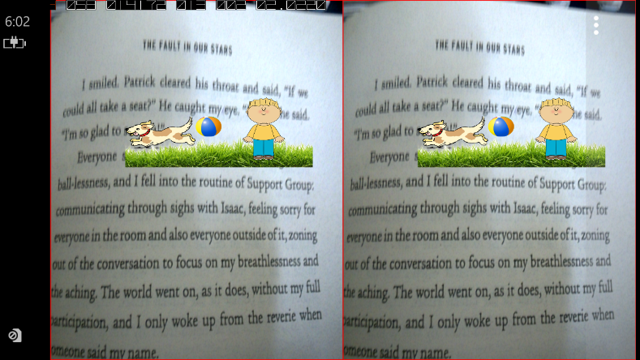

Figure A - 7 VR mode

* To exit the VR mode and go back to initial mode, select back in the menu.

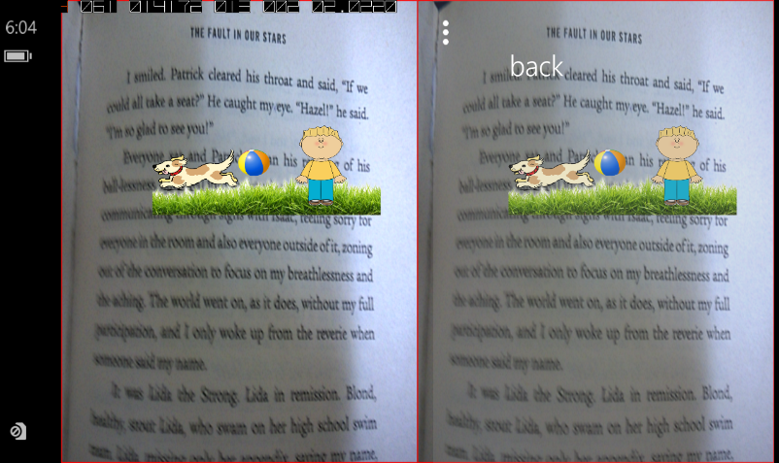

Figure A - 8 Exit VR mode

### A.2.3. Getting goodreads rating

* Select “get rating” in menu to get ratings and reviews from Goodreads



Figure A - 9 Select Goodreads mode

* Point your phone’s camera towards the barcode (ISBN)
* After processing the book’s barcode/ISBN the following output will appear.



Figure A - 10 Ratings and reviews of Goodreads

* To exit this mode select any other mode you want from the menu.

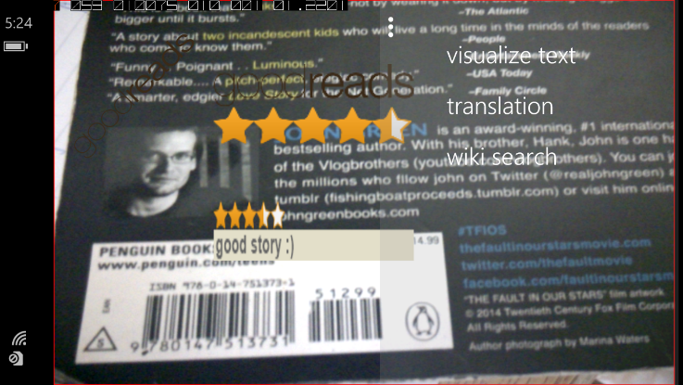

Figure A - 11 Exit Goodreads mode

### A.2.4. Translation

* Select “translation” in menu to get the translation of a word of your selection.



Figure A - 12 Select translation mode

* + Select a word for translation by pointing on it and touching it on your smartphone screen.
  + The output of the translation will appear to you as the figure below.

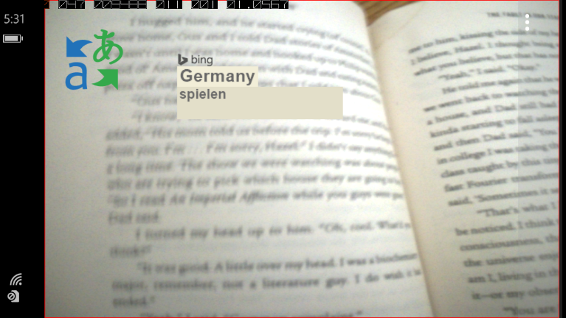

Figure A - 13 A word translated on the screen

* To exit this mode select any other mode you want from the menu.

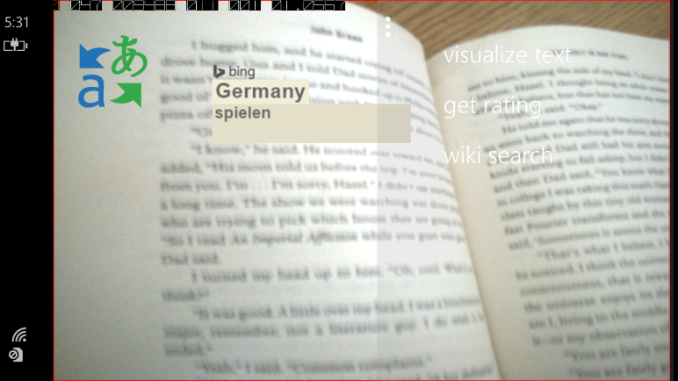

Figure A - 14 Exit translation mode

### A.2.5. wiki search

* Select “Wiki Search” in menu to get information from Wikipedia about a word of your selection.



Figure A - 15 Select Wikipedia mode

* To select a word for Wiki Search by pointing on it and touching it on your smartphone screen.
* The output of the translation will appear to you as the figure below.

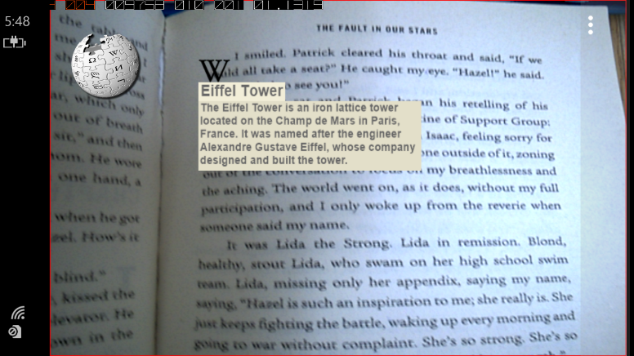

Figure A - 16 Output of Wikipedia mode

* To exit this mode select any other mode you want from the menu.

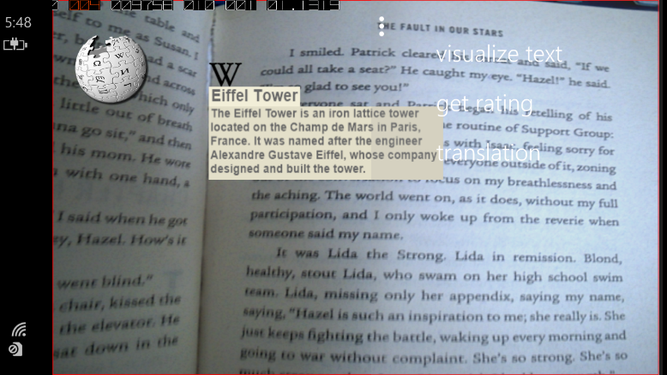

Figure A - 17 Exit Wikipedia mode



# **Appendix-B: Feasibility StuDY**

Appendix B: Feasibility Study

## B.1. Technical feasibility

### B.1.1. Hardware Requirements

* “Durovis Dive 5 VR Glass” check <http://www.durovis.com/index.html> for more details.

### B.1.2. Software Requirements

* Windows phone 8.1

### B.1.3. Input and Output

* **Input:** The text of the book using the smartphone camera, and user input through the buttons in the app.
* **Output:** Graphical illustration representing the text, or an output from the toolkit based on the user’s command.

## B.2. Economic feasibility

### B.2.1. Cost

|  |  |  |  |
| --- | --- | --- | --- |
| Tool | Price (LE) | URL | Justification |
| Microsoft Azure hosting | 900/year | <http://azure.microsoft.com/en-us/services/app-eservice/> | Hosting our RESTful Web api server |
| Nokia Lumia 830 | 3750 | <https://www.microsoft.com/en/mobile/phone/lumia830> | App development and testing |
| Durovis Dive 5 VR Glass | 490 | http://www.durovis.com/index.html | Virtual reality glass for development and testing |

Table B - 1 Rmagine cost

### B.2.2. Benefits

* The app allows you to understand the vocabulary and terms used in the novel in an easy and attractive way.
* It makes picking a good novel easier at bookstores.
* It makes it unnecessary to have a specific background information or knowledge before reading to be able to relate to the book, because you can visualize the lines and search the book terms in Wikipedia.
* Long descriptive details will not be boring anymore because it will be fun to visualize.
* Users will be able to have a boosted reading session without any distractions using the VR glasses.

### B.2.3. Business Model

#### B.2.3.1. Market Segment

* Fiction/crime novel readers from age 15 to 35.
* We are addressing a flourishing market, and our target customers are found where the following users meet:
* Windows phone users (50 million users)
* Novel readers age 15 to 35 (more than 39% of readers)
* Goodreads users (20 million users)
* Fiction/Crime/YA genre fans (Revenue of books sold is more than 1311.9 Million $)

#### B.2.3.2. What we offer to our customers

* Visualization; whenever possible
* Offering a comprehensive toolkit to enhance your reading experience
* Offering pre-rendered/customized animation for your favorite top selling book that we will explain in the next slide

#### B.2.3.3. Product’s MVP:

* Selected supervised text to scene generation in a set of popular books
* Getting the ratings and reviews of a book from Goodreads using OCR
* Displaying the output on the mobile screen and through the VR glass

#### B.2.3.4 Needed investment:

Around 4400 LE (check Table B-1)

## B.3. Operational Feasibility

### B.3.1. Acceptability

* The idea of the app is found attractive by the novel readers
* The bookstores and book authors collaborate with our new technologies and support the idea to offer a new unique service.
* The users feel engaged with the app and use it to access Goodreads features.

### B.3.2. Availability

* Rmagine will be available on the Windows Store and new releases will be available also on Google store.

## B.3. Schedule Feasibility

Figure B - 1 Rmagine Time plan

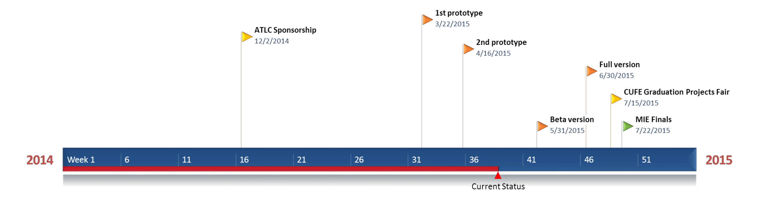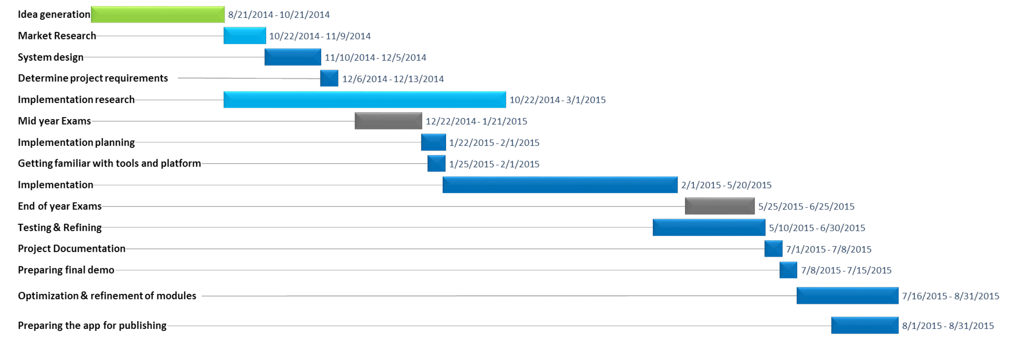

# **ملخص**

ملخص

اللغة الطبيعية وسيلة سهلة وفعالة لوصف الأفكار المرئية والذهنية. لقد لاحظنا التطور في برامج ونظم فهم اللغات الطبيعية وكيف تساعد هذه النظم التعبير عن اللغة عن طريق الصور أو المرئيات بشكل عام مما قد يضيف فائدة كبيرة لمستخدمين هذه النظم. من الأمثلة المشهورة لذلك كيفية توليد مشاهد من الكلمات. العديد من الأبحاث أظهرت ان هذا المجال مطلوب للفترة القادمة والنتائج الأولية أظهرت أمل كبير في التقدم في هذا المجال.

ولقد أثار كل ما سبق شغفنا لنبدأ تجربتنا في هذا المجال. لقد اخترنا الكتب وخاصة القصص والروايات الورقية المكتوبة باللغة الإنجليزية لتكون مصدرنا الأساسي للكلمات. يهدف مشروعنا لجذب القراء لتجربة جديدة من الخيال. نستخدم الواقع الافتراضي والتكنولوجيا والتقنيات الحديثة لنقدم خدمة متميزة لقرائنا عن طريق تحويل الكلمات المعبرة عن مشاهد في القصة لرسوم معبرة عن هذه المشاهد. أيضا نوفر عدة خدمات للقارئ لا يمكن الاستغناء عنها اثناء القراءة.

دمجنا بين أساليب معالجة اللغة الطبيعية وتكوين المشاهد واضفنا عليهم أدوات للقارئ لتصبح هذه فكرة مشروعنا. من اساسيات الفكرة أن نجعل هذه الخدمات متاحة في الهواتف الذكية.

التطبيق الذي ابتكرناه على مستوى جيد جدا من الجودة كأول نسخة لمشروعنا. أثناء العمل على المشروع قابلتنا العديد من الحالات وألهمنا بالكثير من الأفكار التي ستطور التطبيق أكثر وأكثر في المستقبل كما قرأنا العديد من الأبحاث التي شجعتنا على استكمال العمل بالمشرع وتطويره حتى بعد انتهاء السنة و طرحه بالأسواق ان شاء الله.